**INTRODUCTION**

The executive boards of Independent Regulatory Agencies’ (IRAs) hold decision-making, administrative, and financial autonomy, with fixed terms for their directors. This ”identity” itself ensures the independence inherent to the regulatory activity (Cavalcanti and Peci, 2001). Most of the theories that seek to understand IRA’s performance focus mainly on reasons that led to its creation, favoring its emergence as an almost natural consequence of the privatization process of public services or seeing intense mimetic pressures on the part of national and international organizations in the the adoption of this new institutional format (Beblavy, 2011; Christensen and Lægreid, 2005; Jordana et al., 2011). Delegation theories focus mainly on reasons for creating IRAs, as well as on the relationship between the agency (for which power is delegated) and its key policymakers in the post-delegation phase (Gilardi, 2002; Shapiro, 2002).

However, much of the theories mentioned above do not help to understand what happens in IRAs once the regulator delegation process has taken place (Schrefler, 2010). This research intends to depart from a normative orientation about the desirable characteristics of a regulatory body in order to achieve a desirable autonomy of action and seeks to understand if, after more than 20 years since its creation, the real dynamics of the Brazilian regulators approach this rhetoric of independence. The few empirical research that shares this empirical orientation has been carried out in the North American context (Eckert, 1981; Spiller, 1990) and indicate that, after term, regulators are rewarded with well-paid jobs in the regulated industry itself or in its partners and suppliers, corroborating theories of regulatory capture. In other words, IRAs are entities that can be captured by various interest groups.

This paper intends to understand the ”real” autonomy of the executive board. Sharing the premise that expertise and technical knowledge of the regulators are fundamental to assure the autonomy and technical and apolitical nature of the regulator itself, the longitudinal question that guided this research was: How does a change in autonomy affect regulators’ capture? The main goal is to understand how autonomy translates into the capture mechanism. Thus, this research intends to contribute to the ongoing debate and evolution of the studies of the regulatory area in Brazil seeking to map the inherent characteristics of this institutional model of public administration.

**THEORY**

The consolidation of the regulatory role of the State was accompanied by the establishment of specialized agencies that play a regulatory role over private companies in several sectors that include energy, water, telecommunications, pharmaceutical industry, among others, in several countries of the world (Jordana et al., 2011). The IRA model is rescued in this new context of the State’s regulatory role, based on the premise of credibility and guarantee of long-term contracts, in a post-privatization context.

For several authors, IRAs cannot be seen as organizations impervious to the influence of interest groups, since the process of selecting and appointing agency staff reflects some kind of political identity with the incumbent (Justen Filho, 2006; Meirelles and Oliva, 2006; Wu, 2008). Nunes (2007) notes that ”The personalities of independent regulatory authorities are chosen on the merits of the politicians who choose them (which is not a guarantee that such ”merits ”are real) (p.14). The author believes that the existing effort to emphasize that regulatory agencies are politically neutral technical agencies, which exercise imminently technical functions, is, in fact, futile, since they exercise political functions and make political decisions since they result in social and economic repercussions. policies.

On the basis of the questioning of the technicity of the IRAs, many perspectives exist that analyze the agencies from the point of view of capture. Stigler’s (1971) theory of economic regulation already stressed the important aspect of capturing regulators by the regulated industry. In his view, the benefits obtained by interest groups come from the use of the political machine to serve its purposes. Evaluating the industry-related interest groups in the United States, Stigler (1971: 3) states that ”regulation is acquired by industry and is designed and operated primarily for its benefit”.

In Brazil, it is clear to Nunes (2007) that competent people in a certain sector usually work in companies in this sector. It is not surprising, therefore, that the professionals are chosen for their experience and competence often leave regulated companies to join regulatory bodies. In addition, once the term of office has expired and some quarantine period has passed, there will be a desire for the former leader to return to the old place of work, and certainly to more prominent and better-paid places than that occupied before assuming the term in a collegiate board of an IRA.

Among the few empirical studies that have verified the professional trajectory of IRA directors from the point of view of capture, the work of Eckert (1981) and Spiller (1988) stands out. Both developed the methodology used to analyze the career trajectory of the regulators and used the starting point for the operationalization of the present research.

Eckert’s (1981) seminal study demonstrates that the typical career path of regulators consists of a strong performance in the public sector in the run-up to IRA’s direction with a high likelihood of subsequent allocation, either directly or indirectly, to the regulated industry that was under its jurisdiction. During the research, the author noted that the former leader tended to be captured by the companies he regulated. The author points out the rewards that regulators could get from the IRA board, since managers did not receive high salaries (the wage was fixed by statute): there was the expectation of high-paying jobs in the regulated private sector that surpassed the uncertain prospect of re-employment of the position in the board of directors.

One of the main problems of the regulatory agency is the competition between politicians and interest groups for the influence on the decisions of the bureaucrats - regulators. Spiller (1988), based on data previously collected by Eckert (1981), analyzed the regulators of three Interstate Commerce Commission (CAC) and the Federal Communications Commission (FCC) from several (eg: age, term of office, pre-agency and post-agency experience, agency discretionary budget, etc.) to create a model capable of estimating the likelihood that a regulator will act in the regulated industry following as the main determinants for this type of choice.

In some cases, the regulators were appointed to better positions or even positions in the ministry. According to Spiller, this is one of the ways politicians find to reward the regulators who have been faithful to them. He also distinguished the direct employment relationship, that is, an employee of a regulated company, the indirect relationship that means the provision of service to the regulated organization, such as working for a law firm that advises industry on its legal example. The author also points out that regulators have the power to distribute income from regulation. As regulators are appointed by politicians, they are able to derive benefits from potential regulators, whether in the form of advantages for electorally interesting segments or in the form of prior work on their teams.

The competition between politicians and interest groups for the influence on the decisions of the bureaucrats is narrated as one of the main problems of the agency in the seminal study of Spiller. The hypothesis is that much of this compensation takes the form of well-paid post-agency jobs, directly or indirectly related to the regulated economic sectors. In his analysis, working for regulated companies, their partners or suppliers after the end of their term in a regulatory agency may be an indicator that the regulator is rewarded for decisions he has taken to benefit the regulated industry.

In this research, we analyze some critical dimensions regarding the Brazilian regulators’ autonomy, focusing on their professional and political trajectories during pre- and post-term period. Thus, when analyzing these dimensions, it is possible to observe whether, in practice, the autonomy of Brazilian regulators is a myth or a fact, observable in the daily routine of regulation.

**METHODS**

This study draws on balanced panel data over several indicators related to the expertise of regulators from IRAs collegiate boards from 1997 to 2018. The data set covers regulators from ten federal regulatory agencies: National Civil Aviation Agency (ANAC), National Film Agency (ANCINE), National Electrical Power Agency (ANEEL), National Telecommunications Agency (ANATEL), National Waterway Transportation Agency (ANTAQ), National Ground Transportation Agency (ANTT), National Health Surveillance Agency (ANVISA), National Health Agency (ANS), National Petroleum Agency (ANP), and National Water Agency (ANA). Because of its recent creation, the data do not cover the National Mining Agency (ANM), which replaced the previous National Department of Mineral Production (DNPM) in December 2017. The collegiate board from a federal regulatory agency consists of directors chosen by a specific process: the chief of the executive branch, i.e., Brazil’s president appoint them to Senate confirmation before taking over the office.

Our study sample comprises 117 directors’ occupational trajectories five years before and five years after term and report yearly based information. The main source of data is the Federal Senate of Brazil that provides the curricula vitae for every director nominated to compose the collegiate board of a federal regulatory agency. These CVs highlight the academic training, level of education and experience of professionals. We investigated political affiliation in the Supreme Electoral Tribunal (TSE) database, which provides a list of affiliates per party in each state of the federation. We also extract data from the Annual Social Information Report (RAIS), an official registry of all formal workers in Brazil, to capture social characteristics, e.g., employer, occupation according to the Brazilian Classification of Occupations (CBO), compensation and work hours. Finally, we collected both governmental and non-governmental print (newspapers, magazines) and electronic (websites) media to cover information such as allegations of corruption, legal proceedings, and political scandals. Table 1 reports individual variables and data sources considered in this article.

Table 1. Definitions of Study Variables and Data Sources

|  |  |  |
| --- | --- | --- |
| Variables | Definitions | Data Sources |
| Gender | Man or Woman | RAIS |
| Political Affiliation | If one is found on the list of affiliates per party in each state of the federation and/or holds a legislative, administrative or judicial office (either appointed or elected) | TSE and Senate |
| Academia | If one has a Doctoral or Master of Science degree and/or holds a position in academia | Senate |
| Regulatory Agency | If one is a public servant on behalf of a regulatory agency | Senate |
| Public Service | If one is a public servant on behalf of any government department excluding regulatory agencies | Senate |
| Industry | If one works in the regulated industry | RAIS and Senate |
| Consultancy | If one works as a consultant that provides professional advice related to the regulated industry | RAIS and Senate |

Based on the premise that careers are a sequence of job positions over time (Spilerman, 1977), recently one strand in the literature has applied longitudinal data techniques to compare career sequences to map patterns. After some previous results (not shown, but available under request), we observed only marginal differences between trajectories of men and women, academic or non-academic professionals, regulators or public servants in general and private sector workers or consultants. Thus, only two of seven possible dimensions are taken into consideration: politically affiliated vs. non-affiliated and public vs. private sector.

Our empirical strategy follows three paths. First, we analyzed the data using standard statistical techniques, such as descriptive statistics, contingency tables, mosaic plots and chi-squared tests.

Secondly, we employ Optimal Matching Analysis(OMA), introduced in career analysis by Abbott and Hrycak (1990) and revised by Abbott and Tsay (2000), Aisenbrey and Fasang (2010), and Dlouhy and Biemann (2015). The main advantage of applying OMA to our research problem is to deal with career strings without necessarily imposing restrictions regarding the grouping of these strings in common paths. One must notice that in spite of only two dimensions for each state, there are four possible states for each year, thus in theory there are 1,048,576 (410) possible strings.

Briefly, first OMA defines the distance between sequences as the number of changes needed to transform one string of sequence into another. The lower this "cost," the more similar these sequences are. Second, the operations allowed to transform one sequence into another are the substitution, insertion, and elimination (indel operations) of a given state. The output of the comparison between the strings is a symmetric matrix that displays the distance from one sequence to all others. Finally, this matrix is used to cluster sequences that are more or less similar, even though they are not exactly the same.

Thus, we tested explicitly through a binary choice model if political affiliation or previous experience in the public sector influences the probability of working for the private sector after a term in the regulatory board. This simple two-dimension classification proved to be very useful to understand the changes from public to private sector or vice versa, and how political affiliation helps or hampers these transitions.

**DESCRIPTIVE ANALYSIS OF STRINGS**

In spite of the high number or possibilities, there are only 27 strings. The reason for that is the low rate of transitions from one state to the other during the first or last five years of the sequence. When transitions take place, they tend to do before-and-after the term in the regulatory board. This stability may be observed in the tempogram (Figure 1).

Figure 1. Tempogram of the sequences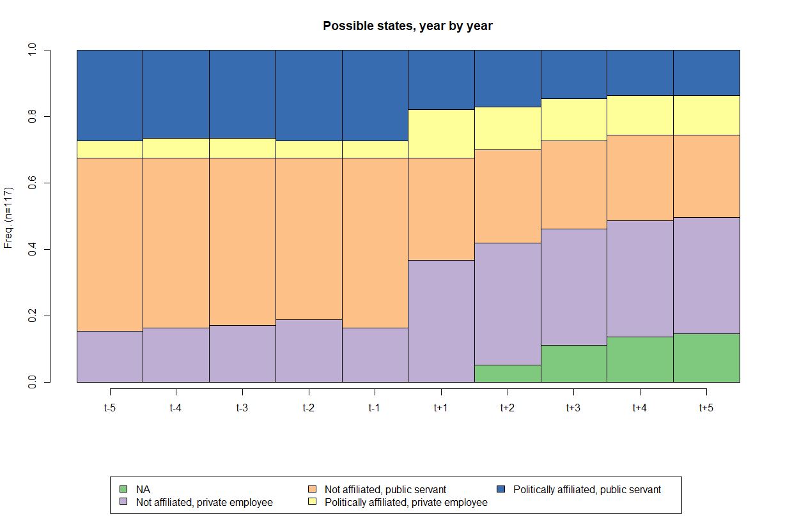

As a result from the low number of observed sequences, ten most common ones correspond to 84.6% of occurrences, as displayed in Figure 2.

Figure 2. Ten most common sequences

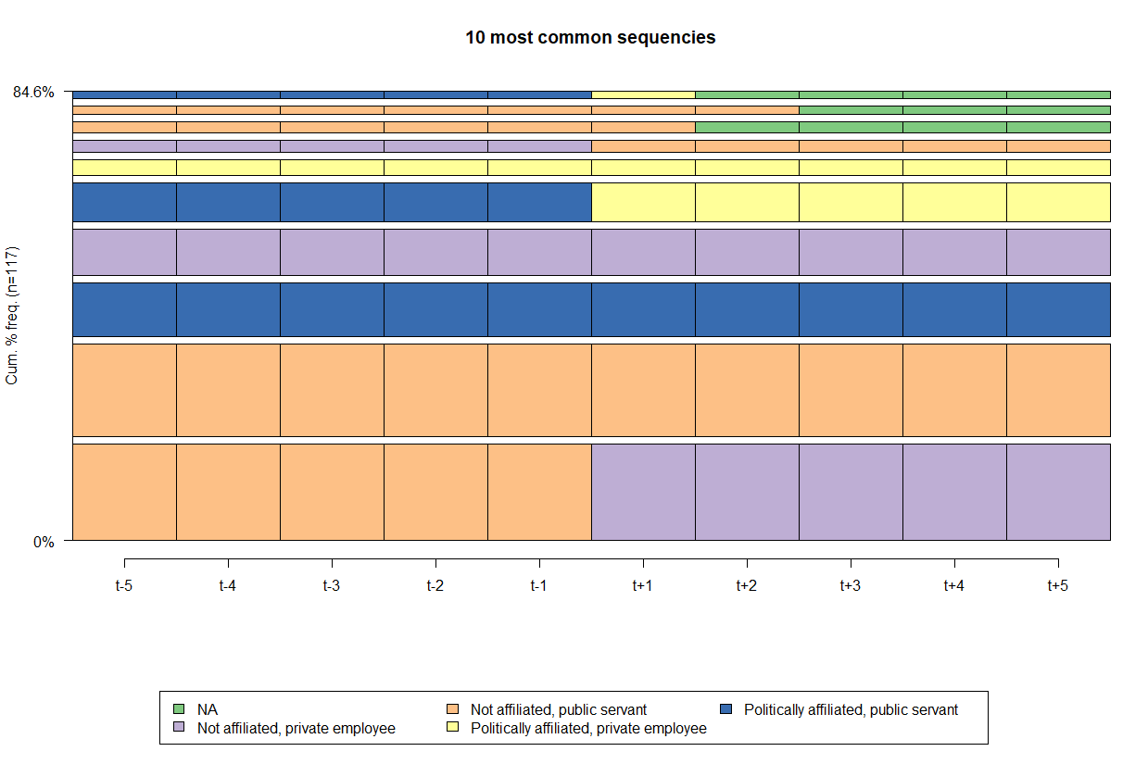

The most frequent string illustrate public servants, without political affiliation, that move to the private sector or become consultants in the regulated area after term (25 occurrencies). The second string shows public servants, without political affiliation, that remain in the public service after term (24). The third string represents public servants, with political affiliation, that remain in the public service after term (14). The fourth string, i.e., private employees, without political affiliation, tend to go back to the regulated private sector (12). The fifth sequence shows public servants, with political affiliation, that are hired by the private sector after term (10). Next, private employees, with political affiliation, remain in the regulated private sector (4). From this simple analysis, one may infer that politicians do not change their positions, i.e., being a politician is not a post-term gain. Neither it precludes of being appointed, nor it guarantees any position post-term. Indeed, most of private sector workers in the after-term come from the public sector, but they are not politically affiliated.

A chi-squared test, a contingency table and a mosaic plot may reveal whether there is some trajectory bias related to IRAs. Indeed, the overall chi-squared test rejects the null hypothesis of no bias towards any IRA, at less than 0.001% of significance. A contingency table and a mosaic plot point out the sources of these biases, through the difference between observed (first line of each cell), expected (second line) and their respective standardized residuals (third line). Standardized residuals may be interpreted as ordinary t-statistic observed values.

Hence, according to traditional confidence levels (10%, 5% and 1% for rejection of the null hypothesis), only two cells show significant differences between observed and expected values. ANAC (the aviation agency) has a larger-than-expected proportion of regulators coming from the private sector (and eventually returning to private jobs), and ANTAQ (the waterway transportation Agency) has the same for affiliated public servants, who return to the public service after their terms.

Table 2. Types of trajectories per agency

|  |  |  |  |  |  |  |
| --- | --- | --- | --- | --- | --- | --- |
| IRA | Others | Always private, not affilliated | Always public, affilliated | Always public, not affilliated | Public to private, affilliated | Public to private, not affilliated |
| ANP | 3  3.06  (-0.04) | 2  1.15  (0.88) | 2  2.2  (-0.16) | 2  0.96  (1.17) | 1  2.3  (-1.01) | 1  1.34  (-0.33) |
| ANAC | 4  3.9  (0.07) | 4  1.46  (2.37) | 1  2.8  (-1.28) | 1  1.22  (-0.22) | 3  2.92  (0.05) | 1  1.7  (-0.61) |
| ANATEL | 4  4.45  (-0.27) | 1  1.67  (-0.59) | 4  3.2  (0.54) | 2  1.39  (0.58) | 3  3.34  (-0.22) | 2  1.95  (0.04) |
| ANCINE | 3  2.78  (0.16) | 1  1.04  (-0.05) | 1  2  (-0.83) | 1  0.87  (0.15) | 2  2.09  (-0.07) | 2  1.22  (0.79) |
| ANEEL | 5  4.17  (0.51) | 0  1.57  (-1.42) | 5  3  (1.38) | 1  1.3  (-0.3) | 2  3.13  (-0.77) | 2  1.83  (0.15) |
| ANS | 5  4.45  (0.33) | 3  1.67  (1.17) | 3  3.2  (-0.13) | 0  1.39  (-1.33) | 3  3.34  (-0.22) | 2  1.95  (0.04) |
| ANTAQ | 1  1.95  (-0.82) | 0  0.73  (-0.93) | 4  1.4  (2.54) | 0  0.61  (-0.84) | 1  1.46  (-0.44) | 1  0.85  (0.18) |
| ANTT | 2  2.23  (-0.18) | 0  0.83  (-1) | 2  1.6  (0.37) | 1  0.7  (0.4) | 3  1.67  (1.2) | 0  0.97  (-1.09) |
| ANVISA | 3  3.06  (-0.04) | 0  1.15  (-1.19) | 1  2.2  (-0.95) | 1  0.96  (0.05) | 4  2.3  (1.33) | 2  1.34  (0.64) |
| ANA | 2  1.95  (0.05) | 1  0.73  (0.34) | 0  1.4  (-1.37) | 1  0.61  (0.54) | 2  1.46  (0.52) | 1  0.85  (0.18) |

Note: observed and expected values in the first two lines, and standardized difference between parentheses.

Figure 3. Mosaic plot: Types of trajectories per agency

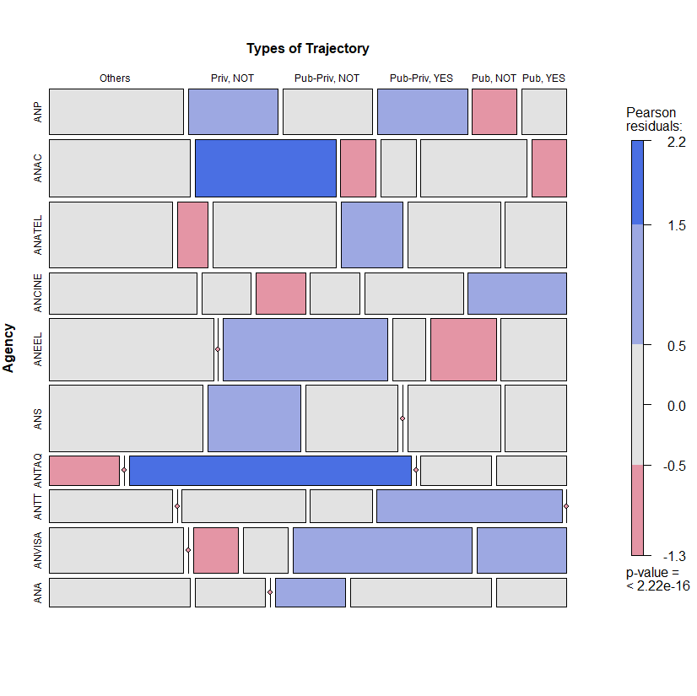

**OPTIMAL MATCHING ANALYSIS**

Besides the coding of sequences and the time frame, there are two critical decisions in applying OMA: the deletion/insertion and replacement costs between the states, when applicable; and the criterion for grouping the sequences. Simulations were conducted using the R statistical programming language. The TraMineR package was used for the sequence analysis, as described by Gabadinho et al. (2011). The TraMineR algorithm is essentially that of Needleman and Wunsch, with standard optimizations (Gabadinho et al., 2011).

The transition costs between states were based on transition probabilities. This choice has been a growing trend in the literature (Aisenbrey and Fasang, 2010; Dlouhy and Biemann, 2015). Mathematically, the transition cost from state *i* to state *j* (*i ≠ j*) is equal to 2 – *p(i|j) – p (j|i)*, where *p(i|j)* is the transition rate between states *i* and *j* in the sample. The rationale behind this approach is that the transitions observed more frequently are less costly than less frequent transitions. By definition, the probability of a transition from one state to itself is equal to one, which makes the transition cost zero.

The clustering method was Ward’s hierarchical cluster, a standard in the literature. The choice of the number of clusters involved the analysis of some measures available in the R cluster package of and visual dendrogram inspection. No definitive criterion to choose the number of clusters exists; some methods and indicators aid researchers in this decision, but they often do not point towards a single solution. In the end, the choice of this number is somehow subjective. Herein, we chose a fourfold solution based on three indicators, the dendrogram and the analytical power of such a solution compared to alternatives. All code used to conduct the simulations and generate plots, as well as the simulation results presented herein, are available upon request.

Figure 4. Dendogram of OMA: 4 cluster solution

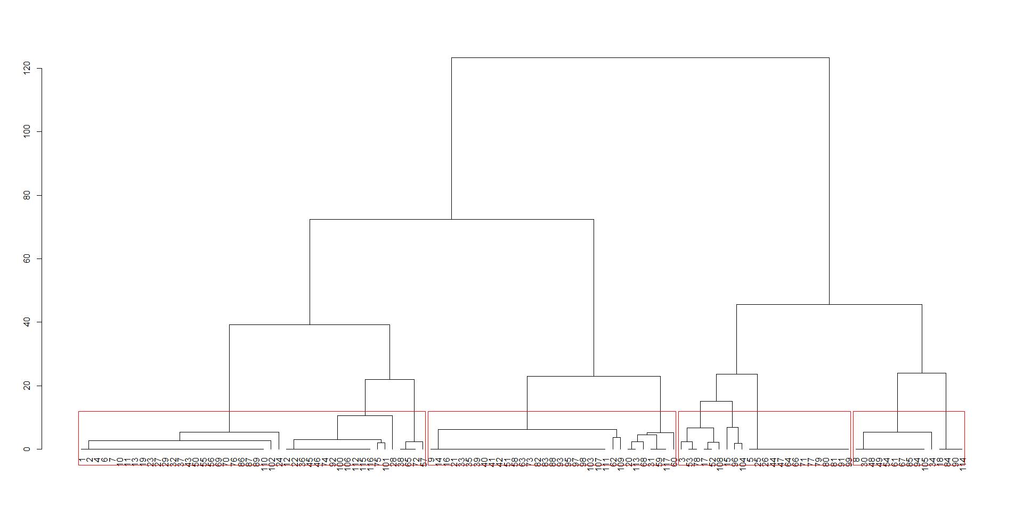

Figure 5. Distribution of states: 4 cluster solution

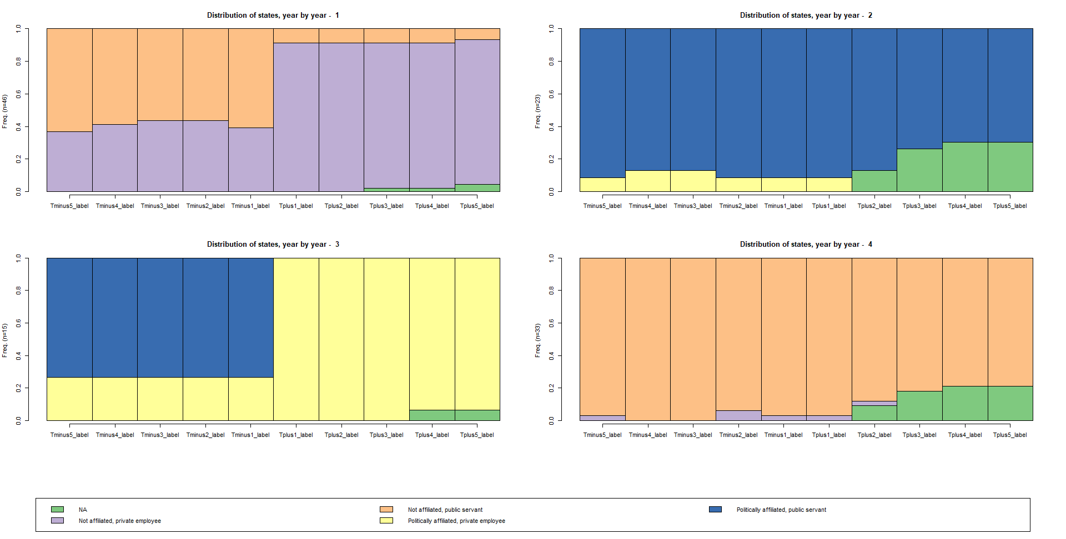

Figure 6. Most common sequences: 4 cluster solution

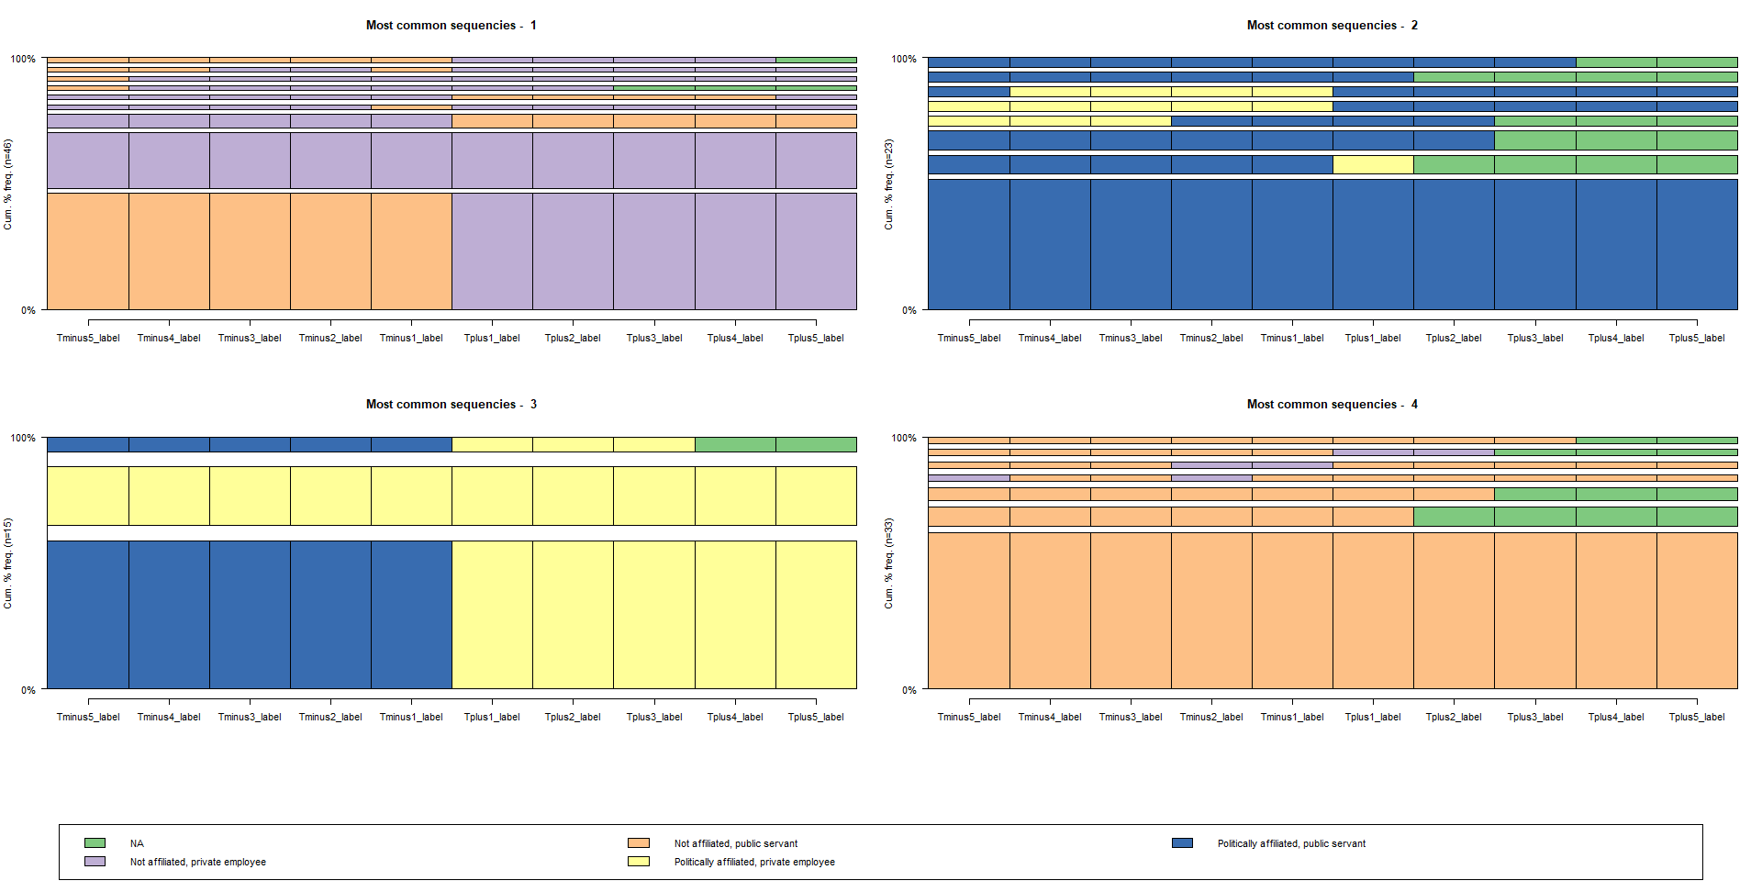

Not surprisingly, the four-cluster solution is very close to the previously presented:

* Cluster 1 (n=46) - public servants, not affiliated, who then become private sector non-affiliated workers;
* Cluster 2 (n=23) – politically affiliated public servants, who return to their positions after their terms as regulators;
* Cluster 3 (n=13) - politically affiliated public servants, who manage to go to the private sector afterwards;
* Cluster (33) – not politically affiliated public servants, who return to their positions.

Thus, OMA analysis complements previous descriptive statistics, in the sense that it shows that most workers who manage to make a transition to the private sector after a term in the regulatory board come from previous public service. Moreover, politics seem not to help them in this transition: only 13 (aprox. 11%) of regulators make the transition from public to private sector bein politically affiliated.

**PROBIT ANALYSIS**

In this section, we test explicitly the hypothesis whether having previous experience in the public sector helps or hampers an afterwards career in the private sector, the same is done for political affiliation.

The first probit model is in table 3. Being a former public servant raises the probability of working in the private sector afterwards. In fact, former public servants have 2.75 more chances to work at the private sector than former private workers do. Politics seems not to affect the after-agency pattern, since one cannot reject the null hypothesis that its coefficient is zero.

Table 3. Probit model (dependent variable: at the private sector after a term as a regulator)

|  |  |  |  |  |
| --- | --- | --- | --- | --- |
|  | Estimate | Std. Error | z value | Pr(>|z|) |
| (Intercept) | -0.975 | 0.464 | -2.103 | 0.036 |
| Previously in public sector | 1.012 | 0.497 | 2.038 | 0.042 |
| Politically affiliated | 0.333 | 0.404 | 0.824 | 0.410 |
| AIC | 162.69 |  |  |  |
| DF | 114 |  |  |  |

We also a run a second model restricted to those former public servants. The underlying hypothesis is that political affiliation may have differentiated effects in the odds of getting a private position depending if the worker comes from the public or private sector. Results are in table 4.

Table 4. Probit model, restricted to public servants (dependent variable: at the private sector after a term as a regulator)

|  |  |  |  |  |
| --- | --- | --- | --- | --- |
|  | Estimate | Std. Error | z value | Pr(>|z|) |
| (Intercept) | 0,033 | 0,256 | 0,128 | 0,898 |
| Politically affiliated | 0,347 | 0,442 | 0,785 | 0,433 |
| AIC | 131.72 |  |  |  |
| DF | 92 |  |  |  |

From this model, one cannot reject the null hypothesis that political affiliation has no impact on the probability of working at the private sector after a term in a regulatory board.

**DISCUSSION**

**CONCLUSION**

REFERENCES

Beblavy, M. (2011). Understanding the waves of agencification and the governance problems they have raised in central and eastern european countries.

Carpenter, D. and Moss, D. A. (2013). Preventing regulatory capture: Special interest influence and how to limit it. Cambridge University Press.

Cavalcanti, B. S. and Peci, A. (2001). Para uma leitura pol´ıtica do ambiente regulatório brasileiro: Agências reguladoras e relações com os principais atores políticos.

Christensen, T. and Lægreid, P. (2005). Regulatory reforms and agencification. Eckert, R. D. (1981). The life cycle of regulatory commissioners. The Journal of Law and Economics, 24(1):113–120.

Gilardi, F. (2002). Policy credibility and delegation to independent regulatory agencies: a comparative empirical analysis. Journal of European Public Policy, 9(6):873–893.

Jordana, J., Levi-Faur, D., and i Marín, X. F. (2011). The global diffusion of regulatory agencies: channels of transfer and stages of diffusion. Comparative political studies, 44(10):1343–1369.

Justen Filho, M. (2006). Agências reguladoras e democracia: existe um déficit democrático na “regulação independente?”. O poder normativo das agências reguladoras, Alexandre Santos de Aragão (Coordenador)...[et al]. Rio de Janeiro: Forense.

Meirelles, F. and Oliva, R. (2006). Delegation and political control of the regulatory agencies in brazil. Revista de Administração Pública, 40(4):545–565.

Nunes, A. J. A. (2007). Breve reflexão sobre o chamado estado regulador. Sequência: Estudos Jurídicos e Políticos, 28(54):9–18.

Schrefler, L. (2010). The usage of scientific knowledge by independent regulatory agencies. Governance, 23(2):309–330.

Shapiro, M. (2002). Judicial delegation doctrines: the us, britain, and france. West European Politics, 25(1):173–199.

Spiller, P. T. (1990). Politicians, interest groups, and regulators: A multiple-principals agency theory of regulation, or” let them be bribed”. The Journal of Law and Economics, 33(1):65–101.

Wu, I. (2008). Who regulates phones, television, and the internet? what makes a communications regulator independent and why it matters. Perspectives on politics, 6(4):769– 783.